Commodity Currency
# Source: AI Source: Provided by: [Data Path: Persons Table -> ID Column: 1, Name_En Column: Motasem Essam] -> From: [ChatGPT] on [7/17/2026]

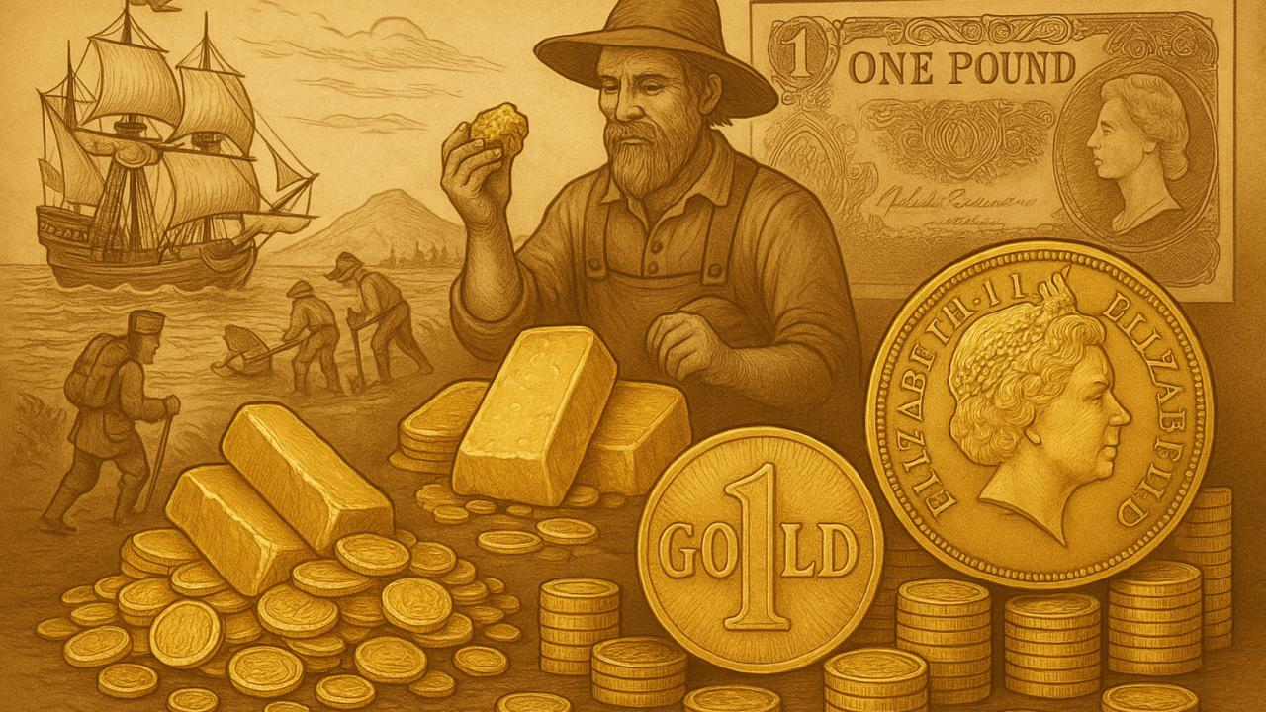
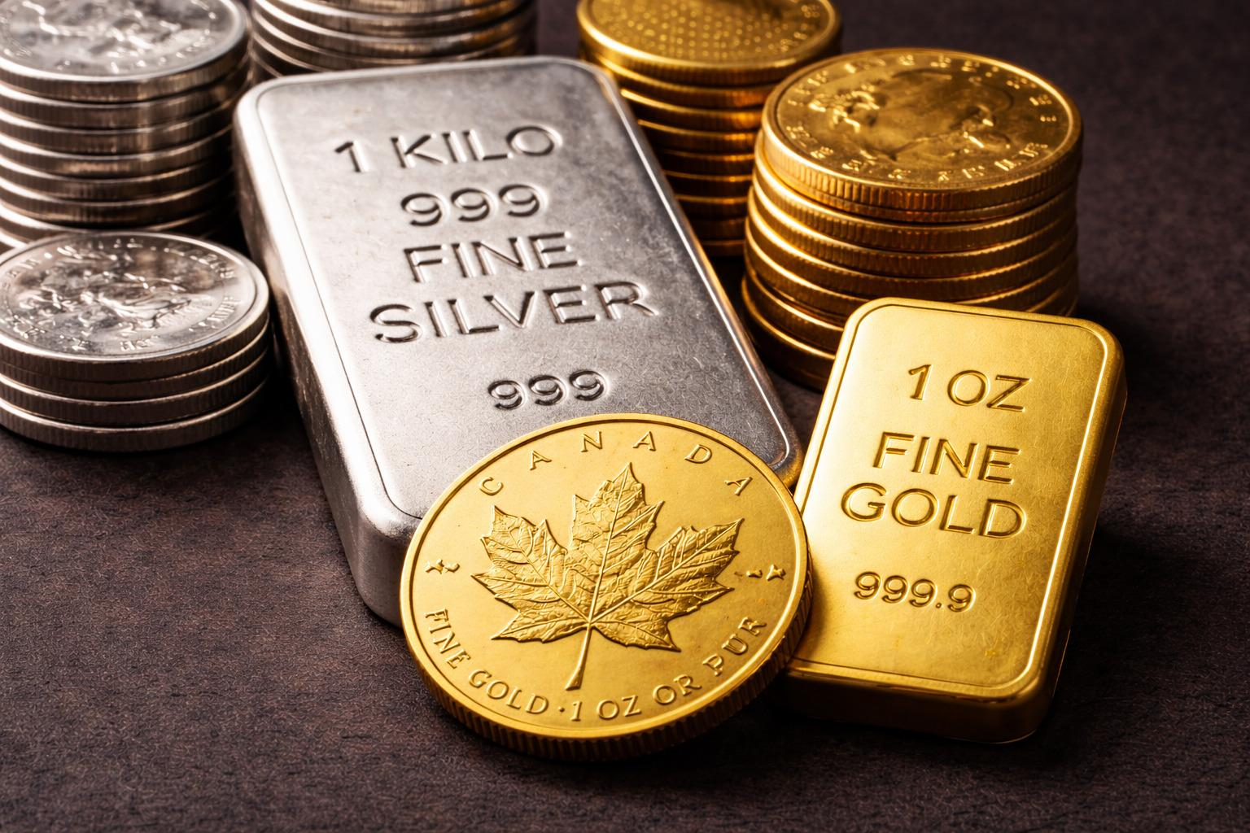
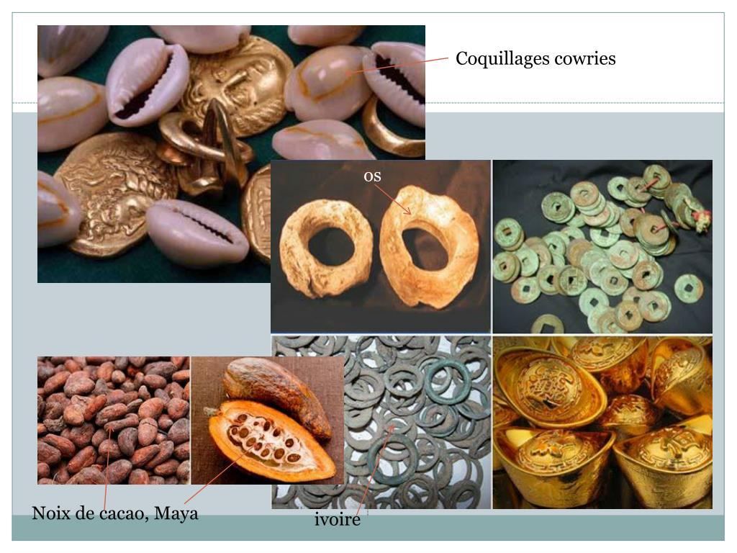

Commodity Currency is a type of currency whose value is directly linked to or backed by a physical commodity, such as gold, silver, or another valuable resource. Unlike fiat currency, which derives its value primarily from government authority and public confidence, commodity currency has value because it is redeemable for a specified amount of the underlying commodity or because the commodity itself serves as money.
Historically, commodity currencies played a major role in international trade and monetary systems, but today they are largely replaced by fiat currencies.

Definition
# Source: AI Source: Provided by: [Data Path: Persons Table -> ID Column: 1, Name_En Column: Motasem Essam] -> From: [ChatGPT] on [7/17/2026]
Commodity Currency is a currency whose value is based on or backed by a physical commodity that has intrinsic economic value, such as gold or silver.

Characteristics of Commodity Currency
# Source: AI Source: Provided by: [Data Path: Persons Table -> ID Column: 1, Name_En Column: Motasem Essam] -> From: [ChatGPT] on [7/17/2026]
Commodity currency is:
- Backed by a tangible asset.
- Redeemable for a specified quantity of that commodity (in systems where convertibility exists).
- Limited by the available supply of the underlying commodity.
- Generally more difficult to expand than fiat currency.

How Commodity Currency Works
# Source: AI Source: Provided by: [Data Path: Persons Table -> ID Column: 1, Name_En Column: Motasem Essam] -> From: [ChatGPT] on [7/17/2026]
In a commodity-backed system:
- A government or monetary authority issues currency.
- Each unit of currency represents a fixed quantity of a valuable commodity.
- Under a fully convertible system, holders may exchange the currency for the underlying commodity.
Example:
- A banknote could represent a fixed amount of gold held in reserve.

Common Commodities Used
# Source: AI Source: Provided by: [Data Path: Persons Table -> ID Column: 1, Name_En Column: Motasem Essam] -> From: [ChatGPT] on [7/17/2026]
Historically, commodity currencies have been backed by:
- Gold
- Silver
- Copper (in some ancient systems)
Other valuable commodities have occasionally been used in trade, such as:
- Salt
- Tobacco
- Tea
- Cocoa beans
However, gold and silver have been the most common commodities used to support formal monetary systems.

Historical Examples

Gold Standard
# Source: AI Source: Provided by: [Data Path: Persons Table -> ID Column: 1, Name_En Column: Motasem Essam] -> From: [ChatGPT] on [7/17/2026]
Under the Gold Standard:
- Currency could be exchanged for a fixed quantity of gold.
- Governments maintained gold reserves to support the issued currency.

Silver Standard
# Source: AI Source: Provided by: [Data Path: Persons Table -> ID Column: 1, Name_En Column: Motasem Essam] -> From: [ChatGPT] on [7/17/2026]
Some countries historically based their currency on:
- Silver reserves

Ancient Commodity Money
# Source: AI Source: Provided by: [Data Path: Persons Table -> ID Column: 1, Name_En Column: Motasem Essam] -> From: [ChatGPT] on [7/17/2026]
Before standardized coins and banknotes, many societies used valuable goods directly as money, including:
- Salt
- Grain
- Livestock
- Precious metals

Advantages
# Source: AI Source: Provided by: [Data Path: Persons Table -> ID Column: 1, Name_En Column: Motasem Essam] -> From: [ChatGPT] on [7/17/2026]
Commodity currency offers:
- Intrinsic value through the underlying commodity.
- Greater protection against excessive money creation.
- Historically lower long-term inflation under well-managed systems.
- Public confidence based on tangible reserves.

Limitations
# Source: AI Source: Provided by: [Data Path: Persons Table -> ID Column: 1, Name_En Column: Motasem Essam] -> From: [ChatGPT] on [7/17/2026]
Commodity currency:
- Limits monetary flexibility because the money supply depends on available reserves.
- Can restrict economic growth if commodity production does not keep pace with demand.
- May be affected by changes in the market value of the commodity.
- Requires storing and protecting physical reserves.

Commodity Currency vs. Fiat Currency
# Source: AI Source: Provided by: [Data Path: Persons Table -> ID Column: 1, Name_En Column: Motasem Essam] -> From: [ChatGPT] on [7/17/2026]
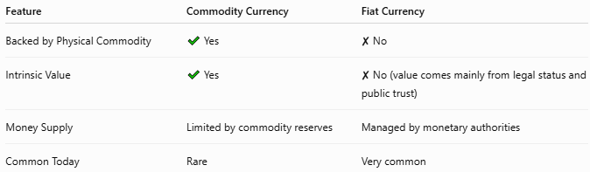
Feature | Commodity Currency | Fiat Currency
Backed by Physical Commodity | ✔ Yes | ✘ No
Intrinsic Value | ✔ Yes | ✘ No (value comes mainly from legal status and public trust)
Money Supply | Limited by commodity reserves | Managed by monetary authorities
Common Today | Rare | Very common

Commodity Currency vs. Representative Money
# Source: AI Source: Provided by: [Data Path: Persons Table -> ID Column: 1, Name_En Column: Motasem Essam] -> From: [ChatGPT] on [7/17/2026]
Although the terms are closely related, they are not identical.
Commodity Currency | Representative Money
Value is tied directly to a commodity. | A certificate or note representing ownership of a commodity.
Historically, paper notes redeemable for gold were a form of representative money used within a commodity-based monetary system.

Applications
# Source: AI Source: Provided by: [Data Path: Persons Table -> ID Column: 1, Name_En Column: Motasem Essam] -> From: [ChatGPT] on [7/17/2026]
Commodity-backed monetary systems were historically used for:
- National currencies
- International trade
- Banking
- Long-distance commerce
Today, commodity currencies are uncommon, although commodities such as gold remain important as investment assets and central bank reserves.

Common Mistakes
# Source: AI Source: Provided by: [Data Path: Persons Table -> ID Column: 1, Name_En Column: Motasem Essam] -> From: [ChatGPT] on [7/17/2026]
- Confusing commodity currency with commodity money.
  - Commodity money is the commodity itself being used as money (for example, gold coins or salt).
  - Commodity currency is currency whose value is tied to a commodity.
- Assuming modern national currencies are backed by gold (most are not).

Interesting Facts
# Source: AI Source: Provided by: [Data Path: Persons Table -> ID Column: 1, Name_En Column: Motasem Essam] -> From: [ChatGPT] on [7/17/2026]
- For much of the 19th and early 20th centuries, many countries operated under the Gold Standard.
- During the 20th century, most nations gradually abandoned commodity-backed monetary systems in favor of fiat currencies.
- Gold continues to play an important role as a reserve asset held by many central banks, even though most modern currencies are no longer directly convertible into gold.

Key Points
# Source: AI Source: Provided by: [Data Path: Persons Table -> ID Column: 1, Name_En Column: Motasem Essam] -> From: [ChatGPT] on [7/17/2026]
- Commodity Currency is backed by a physical commodity.
- Gold and silver have historically been the most common backing commodities.
- Commodity currencies derive value from tangible assets rather than government declaration alone.
- They provide monetary discipline but limit flexibility in managing the money supply.
- Today, nearly all national currencies are fiat currencies, not commodity currencies.

Conclusion
# Source: AI Source: Provided by: [Data Path: Persons Table -> ID Column: 1, Name_En Column: Motasem Essam] -> From: [ChatGPT] on [7/17/2026]
Commodity Currency is a form of currency whose value is directly supported by a physical commodity such as gold or silver. Historically, commodity-backed monetary systems provided stability and public confidence by linking money to tangible assets. However, their dependence on limited commodity reserves reduced monetary flexibility, leading most countries to adopt fiat currencies. Although commodity currencies are now rare, they remain an important part of monetary history and continue to influence discussions about financial stability and the role of precious metals in the global economy.

